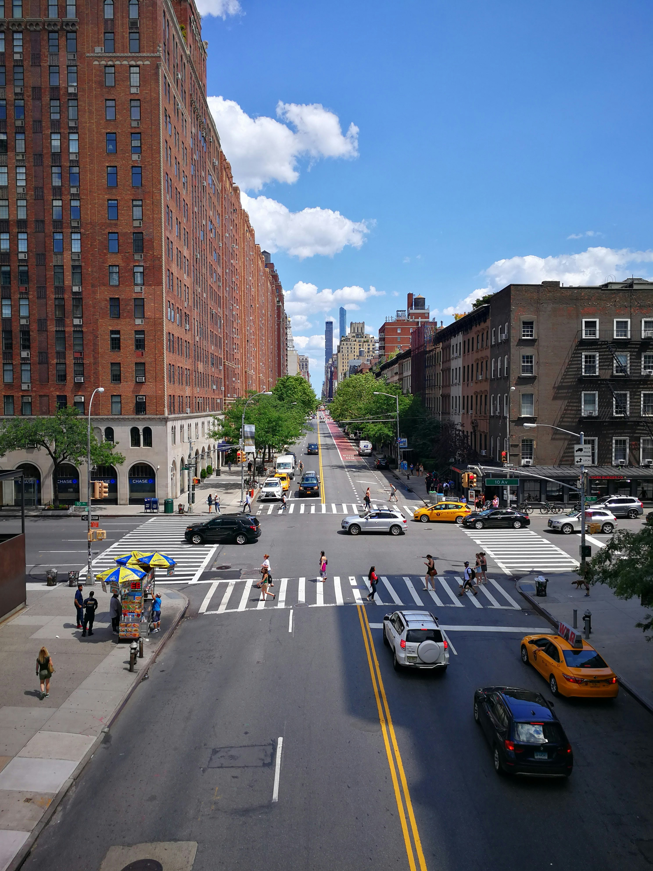
Project Name: [Insert Project Name]

Traffic Impact Assessment Report

Location: [Insert Project Location]
Client: [Insert Client Name]

Prepared by: [Insert Consultant Name/Logo]

Date: [Insert Date]

[Date]
[Project/File Number]
[Recipient Name], [Professional Title if applicable]
[Position]
[Municipality Name]
[Department Name]
[Municipal Address Line 1]
[Municipal Address Line 2]
[City, Province, Postal Code]

Dear [Ms./Mr./Mx.] [Recipient Last Name]:
Subject: Transportation Impact Study – [Project Name Placeholder]
[Consulting Firm Name] has been retained by [Client Name Placeholder] to prepare a Transportation Impact Study (TIS) in support of the proposed development located at [Project Address Placeholder].
This report has been prepared in accordance with the agreed-upon scope of work submitted to [City/Municipal] Transportation staff on [Submission Date Placeholder], and reflects feedback provided by staff through ongoing consultation to confirm the study parameters.
The study evaluates the proposed access strategy including [Primary Access Description Placeholder], and assesses the ability of the surrounding transportation network to accommodate projected site-generated traffic. It also includes an assessment of active transportation conditions, public transit service, vehicle and bicycle parking supply, and on-site loading and servicing requirements.
Please do not hesitate to contact the undersigned should you have any questions regarding the study’s findings or recommendations. I can be reached at [Phone Number Placeholder] or [Email Placeholder].
Sincerely,
[Consulting Firm Name]
[Name Placeholder], [Professional Designations if applicable]
[Title]
[Department, if applicable]

Table of Contents
List of Tables 5
List of Figures 5
List of Appendices 6
Executive Summary 7
1.0 Introduction 9
1.1 Overview of the Proposed Development 9
2.0 Assessment Methodology 11
2.1 Study Area and Intersections 11
2.2 Analysis Periods 12
3.0 Site Description 13
3.1 Description of the Proposed Development 13
3.2 Proposed Site Access 14
4.0 Existing Transportation Conditions 16
4.1 Road Network 16
4.1.1 Arterial Roads 16
4.1.2 Collector Roads 17
4.1.3 Local Roads 17
4.2 Transit Network 18
4.3 Active Transportation 18
5.0 Data Collection 20
5.1 Turning Movement and Midblock Counts 20
5.2 Signal Timing and Phasing Plans 20
5.3 Existing Traffic Volumes 20
6.0 Analysis Methodology 22
6.1 Intersection Capacity Analysis 22
6.2 Model Setup and Calibration 22
6.3 Peak Hour Factor (PHF) 23
6.4 Transit Considerations 23
6.5 Existing Traffic Conditions Analysis 24
7.0 Future Background Transportation Conditions – Without Development 26
7.1 Planned Road Network Improvements 26
7.2 Planned Transit Improvements 26
7.3 Planned Active Transportation Improvements 27
7.4 Background Developments 28
7.5 Background Corridor Growth 28
7.6 Background Traffic Conditions Analysis 29
7.7 Background Traffic Conditions Analysis 30
8.0 Future Transportation Conditions – With Development 31
8.1 Trip Generation 31
8.2 Modal Split 31
8.3 Vehicular Trip Generation (After Modal Split) 32
8.4 Trip Distribution 33
8.5 Trip Assignment 34
8.6 Total Traffic Conditions Analysis 35
8.6.1 Recommended Improvement: Intersection E: Signalization 37
9.0 Future Total Traffic Conditions Analysis with Recommended Improvements 38
9.1 Signalized Access and Trip Reassignment 38
9.2 Total Traffic Conditions with Improvements 39
9.3 Key Findings 39
10.0 Site Plan Review 41
10.1 Minimum Dimensions 41
10.2 Passenger Vehicle Parking and Circulation 41
10.3 Vehicular Circulation 42
10.4 Emergency and Service Vehicle Access 43
10.5 Pedestrians And Cyclists 44
10.6 Transit Impacts 45
10.6.1 Existing Transit Services 45
10.6.2 Planned Transit Improvements 45
10.6.3 Local Improvements 45
10.7 Parking 46
10.7.1 Applicable By-laws 46
10.7.2 Parking Requirements 46
10.8 Proposed Parking Supply 46
10.8.1 Bicycle Parking 47
10.8.2 Proposed Bicycle Parking Supply 48
10.9 Loading 49
10.9.1 Zoning By-law Loading Requirements 49
10.9.2 Proposed Loading Supply 49
11.0 Travel Demand Management Strategies 51
12.0 Conclusions 53
13.0 Recommendations 54
Appendices 55

List of Tables
Table 1: Site Statistics 14
Table 2: Existing Peak Hour Factors 23
Table 3: Level of Service Summary for Existing Traffic Conditions 24
Table 4: Background Developments 28
Table 5: Level of Service Analysis for Background Traffic Conditions 29
Table 6: Trip Generation Summary 31
Table 7: Assumed Modal Split 32
Table 8: Vehicular Trip Generation Summary 32
Table 9: Generalized Site Trip Distribution 33
Table 10: Level of Service Analysis – Total Traffic Conditions 36
Table 12: Level of Service for Future Total Traffic Conditions (Improved) 39
Table 12: Parking Requirements by Land Use 46
Table 13: Proposed Parking Supply 46
Table 14: Minimum Bicycle Parking Requirements 47
Table 15: Proposed Bicycle Parking Supply 48
Table 16: Loading Space Requirements (Zoning By-law) 49
Table 17: Proposed Loading Space Supply 49

List of Figures
Figure 1: Site Location 10
Figure 2: Study Intersections 12
Figure 3: Site Plan 14
Figure 4: Existing Road Network 16
Figure 5: Existing Lane Configurations 17
Figure 6: Existing Transit Network 18
Figure 7: Existing Active Transportation Network 19
Figure 8: Existing Traffic Volumes 21
Figure 9: Future Background Lane Configurations 26
Figure 10: Future Transit Improvements 27
Figure 11: Planned Active Transportation Improvements 28
Figure 12: Background Traffic Volumes 29
Figure 13: Expected Trip Distribution 33
Figure 14: Site Generated Trips 35
Figure 15: Total Traffic Volumes 35
Figure 16: Site Trips Reassignment 38
Figure 17: Future Total Traffic Volumes (Reassigned) 39
Figure 18: Vehicle Circulation - Passenger Car 42
Figure 19: Vehicle Circulation – HSU Truck 43
Figure 20: Vehicle Circulation – Fire Truck 44
Figure 21: Vehicle Circulation – Ambulance 44

List of Appendices
Appendix A - Terms of Reference 56
Appendix B – Traffic Count Sheets 57
Appendix C – Signal Timing Plans 58
Appendix D – Existing Scenario Synchro Output Files 59
Appendix E – Future Background Synchro Output Files 60
Appendix F - Future Total Synchro Output Files 61
Appendix G - Future Total with Improvements Synchro Output Files 62
Appendix H - Vehicle Turning Templates 63

Executive Summary
This Transportation Impact Assessment (TIA) evaluates the anticipated transportation impacts of the proposed [type of] development at [insert site location] and identifies necessary improvements to support its implementation. The study covers [insert number] study intersections and includes analysis of existing, background, and future total traffic conditions, as well as active transportation, transit access, parking, and loading compliance.
Existing Conditions
Traffic operations under existing conditions indicate that most intersections in the study area are operating within acceptable capacity limits during the weekday AM and PM peak hours. Select movements at [insert intersection name(s)] were found to experience minor delays or capacity constraints, largely carried over from historical traffic patterns.
Future Background Conditions
Background traffic volumes were developed by applying a background growth rate of [insert %] per annum and incorporating planned developments within the area. Under future background conditions, most intersections are projected to continue operating within acceptable Levels of Service (LOS), although certain critical movements at [insert intersection(s)] approach capacity.
Trip Generation and Mode Split
Trip generation estimates were developed based on standard industry rates and the proposed land use breakdown. A total of [insert number] trips are anticipated during the AM peak hour and [insert number] during the PM peak hour. A modal split reduction was applied to reflect the proportion of trips expected to occur via transit, walking, or cycling. After accounting for these reductions, net vehicular trips generated by the site are projected at [insert AM trips] AM and [insert PM trips] PM.
Future Total Traffic and Capacity Constraints
Under future total traffic conditions, most study intersections are expected to operate acceptably. However, over-capacity conditions are forecast for select movements at [insert intersection(s)], particularly for turning movements at [insert specific legs or directions]. These constraints are largely carried forward from background conditions and are only marginally impacted by site-generated traffic.
Recommended Improvements
To support site access and mitigate future congestion, the following improvements are recommended:
- Signalization of the [insert access point or intersection], warranted based on future total volumes.
- Modifications to signal timing or phasing at [insert locations], where applicable.
- Enhanced pedestrian and cyclist connections along [insert street or access].
- Reinforcement of the existing street grid by introducing [insert new road / connection if any].
These measures are expected to ensure that site-generated traffic can be safely and efficiently accommodated.
Parking and Loading Compliance
The proposed parking supply of [insert total number] spaces complies with the minimum requirements set out in [insert applicable standard or by-law placeholder]. Bicycle parking facilities, including [insert short term/long term numbers], are also proposed and meet the applicable standards for long- and short-term use.
Loading provisions include [insert number and type of loading spaces], sufficient to support all expected deliveries and on-site servicing. Circulation analysis confirms that standard vehicles including passenger cars, emergency vehicles, and service trucks can be accommodated on-site without operational concerns.

Introduction
[Consulting Firm Name] has been retained by [Client Name] to prepare a Traffic Impact Study (TIS) in support of the proposed [Project Name or Development Type] located at [Site Address or General Location] in the [City/Municipality].
The purpose of this study is to evaluate the transportation impacts associated with the proposed development and to ensure that the surrounding road network and internal site circulation can accommodate the projected traffic demand. The key objectives of the study include:
- Assess the potential multi-modal transportation impacts of the proposed development on the surrounding area;
- Evaluate the cumulative impact of future background growth and nearby developments in conjunction with the proposed project;
- Identify appropriate access locations to the site and determine the necessary access control measures;
- Confirm that the internal road layout and design is sufficient to accommodate expected vehicle types, including passenger vehicles, service vehicles, delivery trucks, and emergency vehicles;
- Estimate the required number of parking spaces to serve projected on-site demand in accordance with local guidelines;
- Evaluate sightlines and access visibility to ensure safe entry and exit points;
- Recommend any transportation infrastructure improvements needed to support access, circulation, and mobility to, from, and within the site.
This report has been prepared in accordance with the requirements of [Approving Authority or Municipality] and reflects the latest available traffic data, planning documents, and transportation policies relevant to the study area.

Overview of the Proposed Development
The development proposal seeks to transform the [Subject Site Name] by leveraging existing and planned infrastructure to support [type of development, e.g., employment, commercial, residential] within the [Name of Planning District or Area]. The proposed development envisions a [size in acres or hectares] master-planned site that supports [land use goals, e.g., intensification, economic growth, mixed-use] while integrating a range of [employment/commercial/residential/mixed-use] activities within urban buildings.
The proposed development will provide approximately [total gross floor area in m² or ft²] of space and is anticipated to support up to [estimated number of jobs/residents/units]. The site will be organized into [number] development blocks (referred to as Site 1, Site 2, and Site 3 for example).
[Client/Developer Name] plans construct a [describe vision, e.g., “multi-use innovation campus”] on the [north/south/east/west] portion of the Subject Site, ensuring high visibility, accessibility, and active frontage along [major street/arterial name]. Remaining portions of the site are planned for [e.g., multistorey office buildings, retail uses, residential towers, institutional facilities], including [if applicable] employee-serving amenities at grade.
The development will be accessed by a new [public/private] roadway that connects [road name A] to [road name B], possibly extending connections to [any trails, active transportation routes, or secondary access roads] through the site. Public realm improvements are also proposed, including [wider sidewalks, street trees, lighting, landscaping, etc.], designed to comply with [e.g., municipal design guidelines, floodproofing requirements, accessibility standards].
The [main anchor use, e.g., Campus, Innovation Hub, Commercial Plaza] is located on the [acreage or parcel name] portion of the site and will include [key components, e.g., showrooms, labs, offices, studios]. The remaining development blocks will feature [building types] with [uses at grade, e.g., retail, amenities]. For the purpose of this Traffic Impact Study, it is assumed that [any assumptions, e.g., office buildings with ground-floor retail] will be developed as described.
The Subject Site is bounded by:
- [North boundary (e.g., road name or landmark)]
- [South boundary]
- [East boundary]
- [West boundary]
A general site location is illustrated in Figure 1.
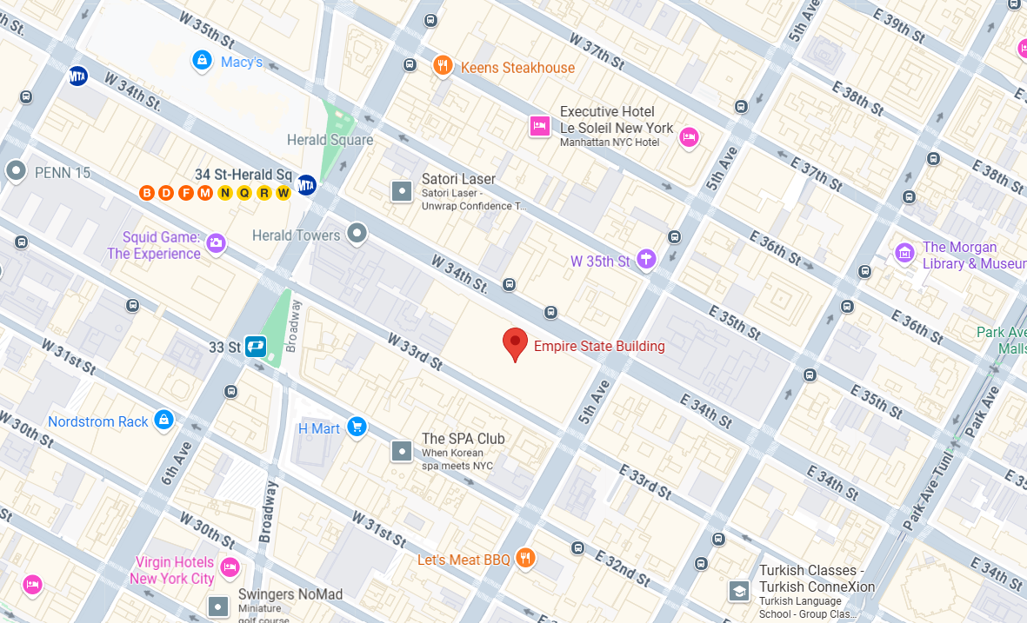
Figure 1: Site Location

Assessment Methodology
A Terms of Reference (ToR) for this Traffic Impact Study (TIS) was submitted to [Municipality/Approving Authority Name] on [Date of Submission]. At the time of preparing this report, a formal written response to the ToR had [not yet been received / been received on DATE with comments incorporated herein].
This study has been prepared in accordance with:
- [Name of Municipality or Region]’s current TIS Guidelines,
- Professional best practices within the transportation planning and engineering industry,
- Guidance obtained through [meetings / telephone calls / emails] with [Municipality or Authority] staff.
If applicable, the submitted Terms of Reference is included in Appendix A.

Study Area and Intersections
The study area was defined based on anticipated traffic patterns and input from [Municipal Authority or Client]. Traffic generated by the proposed development is expected to primarily arrive from and depart toward [geographic directions or planning districts, e.g., northern and western parts of the city], as informed by data sources such as the [e.g., Transportation Tomorrow Survey (TTS), municipal travel demand model, historical traffic data].
Particular consideration was given to truck access, which is expected to originate from nearby major roads such as [Highway or Expressway Name].
The following existing intersections were included in the scope of analysis for this Traffic Impact Study:
- [Street A] / [Street B] – [Signalized / Unsignalized]
- [Street A] / [Street C] – [Signalized / Unsignalized]
- [Street A] / [Street D] – [Signalized / Unsignalized]
(Add as many rows as needed based on study scope and municipal direction)
Additional study intersections may include local driveways and site access points, such as:
- [Street] / [Proposed Site Access A] – [Unsignalized / Signalized]
- [Street] / [Proposed Site Access B] – [Unsignalized / Signalized]
For intersections that do not currently exist but are planned as part of the development, midblock traffic counts were collected on [Street Name] to determine existing traffic volumes and support future scenario modeling. These future intersections analyzed include:
- [Future Intersection 1 Name] – [Signalized / Unsignalized]
- [Future Intersection 2 Name] – [Signalized / Unsignalized]
A map showing all study intersections is provided in Figure 2.
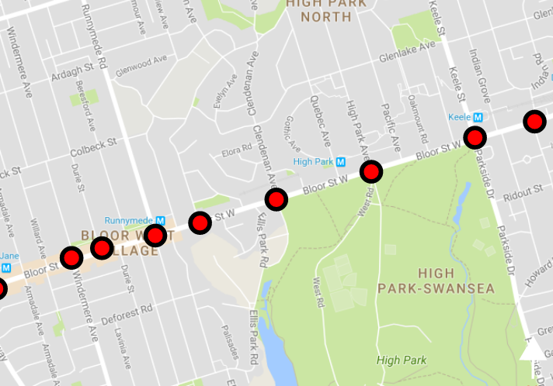
Figure 2: Study Intersections

Analysis Periods
The traffic analysis has been conducted for the following time periods:
- Weekday A.M. Peak Hour (typically 7:00–9:00 a.m.)
- Weekday P.M. Peak Hour (typically 4:00–6:00 p.m.)
These peak periods are generally considered the most critical from a traffic operations perspective, as they represent:
- The highest traffic generation periods for the proposed development;
- The highest background traffic volumes on the surrounding road network;
- The most conservative (i.e., worst-case) conditions for traffic capacity analysis.
Additional time periods (e.g., [Midday, Weekend Peak, Shift Changes, School Dismissals]) may be included based on the development type and municipal requirements.

Site Description

Description of the Proposed Development
The proposed development comprises a [number]-storey multi-use building, accommodating [office space / R&D / dealership / innovation centre / other uses]. The facility is intended to serve as a hub for [industry type, e.g., mobility, tech, or healthcare], combining [corporate / public-facing / service] functions under one roof. The total gross floor area of Site 1 is approximately [XX,XXX] m², excluding structured parking.
In addition to Site 1, the proposal includes Site 2 and Site 3 to the [north / east / etc.] of the subject property. These blocks are envisioned to support up to [XX,XXX] m² of [office / institutional / employment] uses and approximately [XX,XXX] m² of employee-serving retail or service space. Final configurations of these sites remain conceptual at this stage.
Structured and surface parking will be provided across all phases. A portion of parking will be allocated to [public use / staff / customers], with separate provisions made for [vehicle inventory / loading / deliveries] where applicable. The number of required parking spaces is addressed in Section 10 of this report.
A proposed site plan is shown in Figure 3, and a summary of gross floor areas is provided in Table 1.
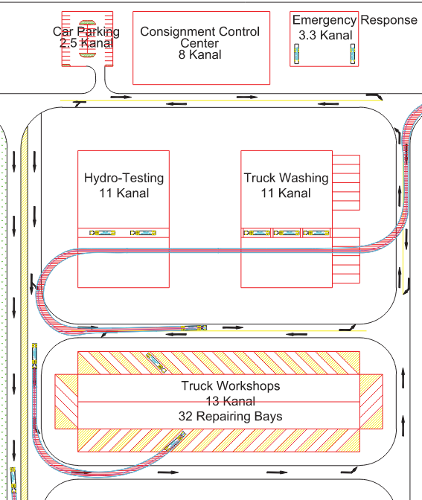
Figure 3: Site Plan
Table 1: Site Statistics
Land Use | Area/Units
Residential | [XX]
Commercial | [XX]
Apartments | [XX]
Industrial | [XX]
…… | [XX]
Total | [XX]

Proposed Site Access
[Connector Road Name] Extension
A new public road, referred to as the [Connector Road Name] Extension, is proposed to run north-south through the Subject Site, connecting [northern road, e.g., Eastern Avenue] to [southern road or trail, e.g., Lake Shore Boulevard or Don Recreational Trail]. This two-way road is envisioned as a [low-speed / multimodal] corridor, improving circulation through the site and offering an additional connection for pedestrians, cyclists, and vehicles. The cross-section includes a [XX]-metre right-of-way, [XX] metres of pavement, and sidewalks on both sides.
Site Access Points
Several access points are proposed to support circulation to and from the development:
- [Southern Road] / [Connector Road] Extension (Right-in/Right-out):
This access point is expected to serve as the primary vehicular entrance for Site 1, accommodating both passenger vehicles and larger delivery trucks (e.g., [type of truck]). It provides direct access from [major road] and helps divert heavy vehicle traffic away from [residential area or sensitive land use] to the north.
- [Northern Road] / [Connector Road] Extension (Full-Moves):
A full-moves access is proposed at the intersection of [Connector Road] and Northern Road, with traffic signals recommended in Phase [X] to manage two-way flows for Sites [X and X]. This intersection will support both employee and visitor access and enhance connectivity to the surrounding road network.
- [Northern Road] / Existing [West/East] Driveway:
An existing driveway on [northern edge of the site] will be retained to serve [Site 2 / Site 3], primarily functioning as a private access for parking and service areas.
Internal Circulation
A private road is proposed within the site, connecting to the [Connector Road Name] Extension and providing access to key internal functions such as [vehicle service areas, loading docks, structured parking ramps, etc.].
The proposed road network—comprising both public and private elements—is illustrated in Figure [X]. All new internal roads and access points are anticipated to be operational by the opening of Phase [1 / the initial development phase].

Existing Transportation Conditions
This section summarizes the existing transportation conditions in the vicinity of the Subject Site, including the road network, transit service, and active transportation infrastructure.

Road Network
The site is located within an established urban context with access to a range of transportation facilities. The study area includes [X] arterial roads, [X] collector roads, and several local roads. The existing road network is illustrated in Figure 4.
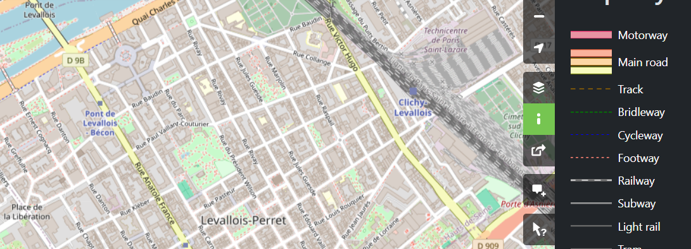
Figure 4: Existing Road Network

Arterial Roads
The major arterial and minor arterial roads within the study area include:
- [Arterial Road 1 (e.g., This Boulevard)]
A major east-west arterial forming the [northern/southern/eastern/western] boundary of the Subject Site. It typically includes [number] lanes, signalized intersections at key locations, and posted speed limits of [XX km/h]. Active transportation facilities such as [bike lanes / trails / sidewalks] are also provided.
- [Arterial Road 2 (e.g., That Avenue)]
A minor arterial with [number] lanes and sidewalks on both sides. On-street parking is [permitted/not permitted] on [north/south/either] sides. Bike lanes are available in [both directions / one direction], and the speed limit is [XX km/h].
- [Arterial Road 3 (e.g., Some Street East)]
A transit-oriented arterial road with embedded [streetcar tracks / bus lanes]. The road includes [number] lanes, sidewalks on both sides, and regulated on-street parking. The posted speed limit is [XX km/h].
- [Arterial Road 4 (e.g., The Street)]
A north-south arterial intersecting key east-west corridors such as [Lake Shore Boulevard / Eastern Avenue]. Sidewalks are provided on both sides. On-street parking is [restricted/permitted], and the speed limit is [XX km/h].

Collector Roads
- [Collector Road Name (e.g., Some Avenue)]
A north-south collector intersecting [Arterial A], [Arterial B], and [Arterial C]. It consists of [number] lanes, sidewalks, and designated parking areas. Speed limits vary by segment, with [XX km/h] north of [road name] and [XX km/h] south of it.

Local Roads
Several one-way and two-way local residential roads provide access within the neighborhood. These include:
- [Road Name (e.g., Jack Avenue)] – A two-way local street with sidewalks and [bus/streetcar] service (Route #). Permit parking is allowed on [one/both] sides.
- [Road Name (e.g., Jill Avenue)] – A [northbound/southbound] one-way road terminating at [road name], expected to be extended in the future.
- [Road Name (e.g., Hill Avenue)] – A one-way [northbound/southbound] local street with sidewalks and on-street permit parking.
- [Road Name (e.g., Fetch Avenue)] – A one-way local street with a posted speed of [30/40 km/h] and sidewalks on both sides.
- [Road Name (e.g., Pale Avenue)] – A one-way street with [parking/sidewalks] on [east/west] side and posted speed of [XX km/h].
- [Road Name (e.g., Water Street)] – A short connector road of [approximate length], with assumed speed limits of [XX km/h].
Figure 5 illustrates the existing lane configurations on all study roadways.
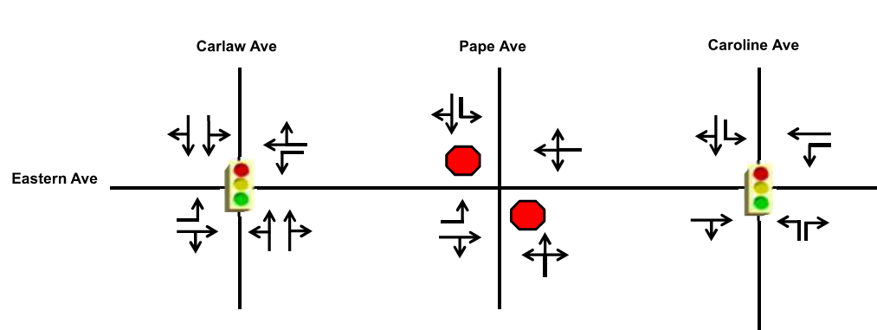
Figure 5: Existing Lane Configurations

Transit Network
The site is served by multiple transit [bus and/or streetcar] routes operating on nearby arterial and collector roads. Major services include:
- [Route # and Name] – Operating along [road name]
- [Route # and Name] – Peak-hour express route serving [road name]
- [Streetcar Route #] – Providing east-west service on [Queen Street East / other]
The nearest major transit corridor is [Queen Street East / another], which connects to the broader public transit network. An overview of the existing transit network is presented in Figure 6.
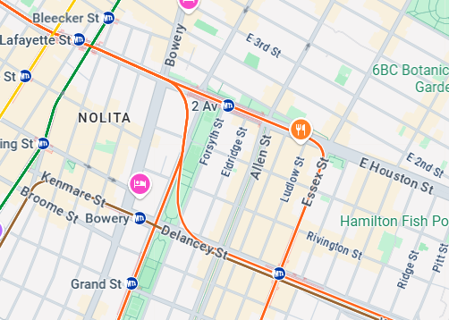
Figure 6: Existing Transit Network

Active Transportation
Active transportation facilities in the area include:
- On-street bike lanes on [Avenue 1 / other roads]
- Multi-use trails, such as the [Lower Don Recreation Trail], running adjacent to [Lake Shore Boulevard / another road]
- Sidewalks are generally available on both sides of most arterial, collector, and local roads in the study area.
The existing active transportation routes are shown in Figure 7.
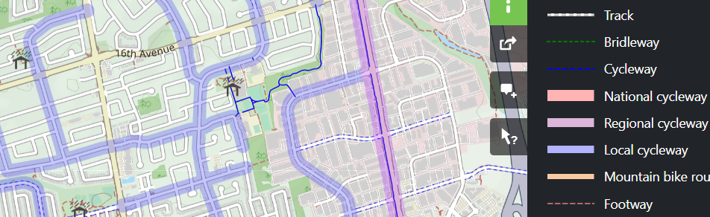
Figure 7: Existing Active Transportation Network

Data Collection
Traffic data were collected to establish baseline conditions for the transportation analysis. These data include intersection turning movement counts, midblock counts, and traffic signal timing information, as described below.

Turning Movement and Midblock Counts
Intersection turning movement counts and midblock volume counts were conducted on [Day of Week, Date] at all study intersections and road segments, except for [List any intersections not initially counted].
Following a meeting with [City/Municipal] staff on [Date], additional intersections were added to the study area. Corresponding turning movement counts for these locations were collected on [Day of Week, Date].
Traffic data were collected during the following periods, consistent with standard weekday commuter peak hours:
- A.M. Peak Period: 7:00 a.m. to 9:00 a.m.
- P.M. Peak Period: 4:00 p.m. to 6:00 p.m.
The full count data are included in Appendix B.

Signal Timing and Phasing Plans
Signal timing and phasing information for all existing signalized intersections within the study area were obtained from the [City/Municipality]. These include:
- Cycle length
- Green time and phasing details for each approach
- Pedestrian crossing timings
This information was used in the capacity analysis and is provided in Appendix C.

Existing Traffic Volumes
The existing peak hour traffic volumes at study intersections and along midblock segments are illustrated in Figure 8.
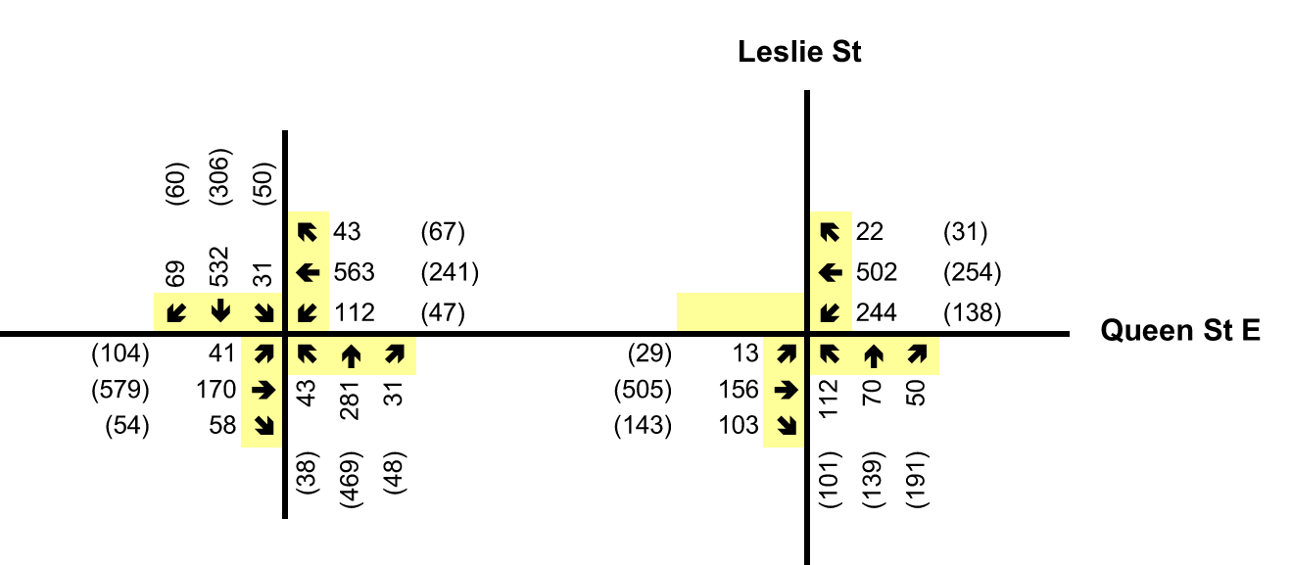
Figure 8: Existing Traffic Volumes

Analysis Methodology
This section describes the methodology used to assess existing and future traffic conditions at study intersections, focusing on intersection delay, level of service (LOS), and volume-to-capacity (v/c) ratios.

Intersection Capacity Analysis
Intersection capacity analyses were conducted using Synchro [Version Number] traffic analysis software. The methodology follows the procedures outlined in the Highway Capacity Manual ([Edition, e.g., HCM Xth Edition]), published by the Transportation Research Board.
The analysis provides:
- Level of Service (LOS) for each intersection, based on average control delay;
- Volume-to-capacity (v/c) ratios for individual turning movements.
LOS is categorized from A (free-flow conditions) to F (excessive delays). LOS A–D are generally considered acceptable, while LOS E and F indicate congestion.
The analysis includes:
- Overall LOS for each intersection;
- Identification of critical movements with v/c ≥ 0.85 on arterial roads;
- Evaluation of potential signalization needs for unsignalized intersections under future scenarios.
For all future year analyses, signal timing plans were [optimized / held constant / modified based on projected volumes]. Introduction of geometric improvements of signal phases are documented for each analysis horizon.

Model Setup and Calibration
The study intersections and road network were modelled in Synchro to replicate real-world conditions. Inputs included:
- Lane configurations, as per field observation and design drawings;
- Signal timing and phasing, based on data provided by [City/Municipality];
- Traffic volumes, based on turning movement counts;
- Intersection control types (signalized, stop-controlled, etc.).
Calibration was performed to ensure v/c ratios reflect realistic operations. This included adjusting lost time where needed (typically between 1–3 seconds), accounting for driver behavior during the yellow interval.
Parking lanes and other adjacent road characteristics were coded into the model as described in Section [X].

Peak Hour Factor (PHF)
The Peak Hour Factor (PHF) was calculated at each study intersection using the following formula:
$$PHF= \frac{Hourly Volume}{4×Volume during peak 15-minute interval}$$
PHF values were applied to all movements at each intersection and used consistently across:
- Existing conditions analysis;
- Future background analysis;
- Future total traffic analysis.
Table 2 summarizes the Peak Hour Factors (PHFs) calculated for each study intersection during the a.m. and p.m. peak hours. These PHFs were derived from traffic count data using the standard formula and applied consistently across the operational analysis for existing, background, and total traffic scenarios.
Table 2: Existing Peak Hour Factors
Intersection | PHF AM | PHF PM
[Intersection Name 1] | [0.XX] | [0.XX]
[Intersection Name 2] | [0.XX] | [0.XX]
[Intersection Name 3] | [0.XX] | [0.XX]
… | … | …
[Proposed Intersection A]* | [0.XX] | [0.XX]
[Proposed Intersection B]* | [0.XX] | [0.XX]
*PHFs for proposed intersections were determined using midblock traffic counts conducted on [Road Name] between [From Street] and [To Street].

Transit Considerations
In accordance with [City/Municipality] Traffic Impact Study Guidelines, transit operations were considered in the traffic modeling of [Street Name]. The excerpt below was referenced for modeling assumptions:
“If transit occupies a mixed traffic lane and the frequency is more than one every five minutes in each direction, then the transit lane should be excluded from the analysis along with any left turn movements. The reason for excluding the lane from the analysis is that transit stops impede the flow of traffic in the transit lane and hinder the flow in the curb lane when passengers board and alight the transit vehicles. If a left/through shared lane has an advanced phase, then the transit lane should be coded as a left turn lane only (and not as a shared through/left lane).”
As per the above, [Street Name] was modeled as a [Number]-lane road [with / without] left-turn movements, except at the intersection of [e.g., Queen Street and Leslie Street], which includes a dedicated left-turn phase.

Existing Traffic Conditions Analysis
Existing traffic volumes and signal timing/phasing data were input into [Software Name, e.g., Synchro 12] to assess current levels of service (LOS) and identify critical movements at intersections within the study area. These base conditions form the foundation for determining the potential impacts of the proposed development on the surrounding transportation network.
The analysis of existing conditions is summarized in Table 3. Detailed Synchro output sheets are included in Appendix D.
Table 3: Level of Service Summary for Existing Traffic Conditions
Intersection | Control Type | AM Peak Hour |  |  | PM Peak Hour
Intersection | Control Type | LOS | Delay (s) | Critical Movement(s) (v/c) | LOS | Delay (s) | Critical Movement(s) (v/c)
[Intersection Name 1] | Signalized | B | 16 | EB-TR (1.01) | C | 30 | EB-TR (1.01)
[Intersection Name 2] | Signalized | B | 16 | — | B | 15 | —
[Intersection Name 3] | Unsignalized | A | 0 | — | A | 0 | —
[Intersection Name 4] | Signalized | B | 13 | EB-TR (0.94) | C | 27 | EB-TR (0.94)
[Intersection Name 5] | Signalized | C | 21 | EB-TR (0.90), NB-LTR (0.90) | C | 30 | EB-TR (0.90), NB-LTR (0.90)
… | … | … | … | … | … | … | …
Notes: The LOS at an unsignalized intersection is defined by the movement with the highest delay. Critical movements are those with a v/c > 0.85 (signalized) or LOS E/F (unsignalized).
The majority of intersections within the study area are currently operating at acceptable levels of service with minimal delays during both the a.m. and p.m. peak hours. However, the analysis identified the following performance issues:
- [Intersection of Street A and Street B] and [Intersection of Street C and Street D] are operating near capacity during the p.m. peak hour.
- [Intersection of Street A and Street E], [Intersection of Street F and Street E], and [Intersection of Street F and Street G] show select movements operating over capacity, including:
  - Eastbound Left movement at [Street F / Street E] with volume-to-capacity (v/c) ratio exceeding 1.5;
  - Westbound Through-Right movement at [Street F / Street G] with v/c ratio exceeding 1.3.
It is noted that v/c ratios greater than 1.0 under existing conditions are likely due to conservative assumptions in the analysis software or discrepancies between modeled and field conditions. Observed traffic operations indicate that these movements generally clear within the peak hour, suggesting they are more accurately described as at or near capacity.

Future Background Transportation Conditions – Without Development

Planned Road Network Improvements
The following planned improvements to the area’s transportation infrastructure have been identified through municipal plans, area studies, or development applications. These improvements, while independent of the proposed development, may influence traffic conditions in the study area and have therefore been considered in this analysis.
Planned improvements may include (modify/add as applicable):
- New road connections or extensions, such as extending an existing road to provide alternative access routes.
- Intersection modifications, including installation or relocation of traffic signals, changes to stop control, or geometric modifications such as added turning lanes.
- Lane reconfigurations, including changes from shared lanes to dedicated turning lanes, or addition/removal of travel lanes.
- Changes to access management, such as new driveways, restricted turning movements, or consolidation of site access points.
- Traffic calming measures or speed control strategies.
Where applicable, these improvements have been incorporated into the future background traffic scenarios. The future background network / lane configuration reflecting these improvements is shown in Figure 9.
Figure 9: Future Background Lane Configurations

Planned Transit Improvements
Planned or committed transit improvements in the study area, as identified through official plans, transit agency reports, or infrastructure studies, have been reviewed for their potential impact on travel behaviour and site accessibility. These may include:
- New or restructured bus routes, including changes in frequency or service span.
- Introduction or expansion of light rail/streetcar service along adjacent or connecting corridors.
- Subway or commuter rail expansions, with new stations proposed within walking distance of the site.
- Transit priority measures, such as dedicated lanes, queue jump lanes, or transit signal priority at intersections.
These improvements have been considered qualitatively or quantitatively, depending on the availability of planning detail and implementation timelines. Where relevant, they are illustrated in accompanying figures (e.g., Figure 10).
Figure 10: Future Transit Improvements

Planned Active Transportation Improvements
Planned active transportation improvements in the study area have been identified through municipal planning documents, area secondary plans, or infrastructure studies. These improvements aim to enhance safety, connectivity, and comfort for pedestrians and cyclists in and around the site.
Planned improvements may include (consultant to specify, as applicable):
- New or upgraded sidewalks to improve pedestrian access along key corridors.
- Cycle tracks or dedicated bike lanes on adjacent or nearby roadways.
- Multi-use trails or shared-use paths connecting the site to nearby parks, transit stations, or key destinations.
- Improved pedestrian crossings, including signalized crosswalks, pedestrian refuge islands, or curb extensions.
- Bicycle parking facilities, either on-site or within the public right-of-way, to encourage cycling as a viable mode of access.
These improvements are intended to increase accessibility to the site for non-motorized users and promote a mode shift toward active transportation. Where applicable, these planned facilities are illustrated in Figure 11.
Figure 11: Planned Active Transportation Improvements

Background Developments
In consultation with [City/Town Name] staff and based on recent development activity in the vicinity of the site, several background developments have been identified to be incorporated into the future baseline traffic analysis. These developments are expected to be fully or partially built and occupied by the future analysis horizon year.
A brief description of the background developments is provided in Table 4 below.
Table 4: Background Developments
Background Development Address/Name | Development Description
[Address or Name 1] | [e.g., ___ residential units + ___ m² office + ___ m² retail]
[Address or Name 2] | [e.g., ___ residential units + ___ m² commercial]
[Address or Name 3] | [Insert description]
[Etc.] | [As needed]

Any additional developments not included in this assessment were either outside the study horizon, in early planning stages, or explicitly excluded per direction from [Municipal Authority or Staff Name].

Background Corridor Growth
In consultation with [City/Town Name] staff and relevant transportation studies for the area, no additional general growth was applied to the traffic network beyond the trips generated by the identified background developments. It is assumed that the combined traffic from the background developments sufficiently captures growth on the surrounding road network for the analysis horizon year.
(Alternatively: _A uniform background growth rate of __% per year was applied to traffic volumes on key corridors to reflect expected corridor growth.)

Background Traffic Conditions Analysis
Background traffic conditions reflect the anticipated transportation network and traffic activity at the analysis horizon year [e.g., 2029], assuming the site is not yet developed. These conditions incorporate:
- Traffic volumes from the identified background developments;
- Planned road network improvements, including:
  - [e.g., road extensions, added signals, lane modifications];
- Updated intersection control and lane configurations;
- Signal timing optimization based on background volumes.
Background traffic volumes were developed by combining existing counts with the anticipated trips from background developments. The adjusted traffic volumes and lane configurations were input into [Synchro/Other Software] to evaluate intersection operations under background conditions. Results are summarized in Table 5. Full Synchro output is provided in Appendix E.
Figure 12: Background Traffic Volumes
Table 5: Level of Service Analysis for Background Traffic Conditions
Intersection | Control Type | AM Peak Hour |  |  | PM Peak Hour
Intersection | Control Type | LOS¹ | Delay (s) | Critical Movements² (v/c) | LOS¹ | Delay (s) | Critical Movements² (v/c)
Intersection A / Street B | [Signalized / Unsignalized] | [A-F] | (__) | [e.g., EB-TR (0.91)] | [A-F] | (__) | [e.g., NB-LTR (1.03)]
Intersection C / Street D | [Signalized / Unsignalized] | [A-F] | (__) | [If any] | [A-F] | (__) | [If any]
... | ... | ... | ... | ... | ... | ... | ...
Intersection X / Street Y | [Signalized / Unsignalized] | [A-F] | (__) | [If applicable] | [A-F] | (__) | [If applicable]
Notes: 1. LOS at an unsignalized intersection is defined by the movement with the highest delay. 2. Critical movements are those with a volume-to-capacity (v/c) ratio exceeding 0.85 for a signalized intersection or movements with LOS of E or F at an unsignalized intersection.
Direction Codes: NB = northbound; SB = southbound; EB = eastbound; WB = westbound; L = left; T = through; R = right

Background Traffic Conditions Analysis
Most of the study intersections are projected to operate at acceptable Levels of Service (LOS) during the weekday [a.m.] and [p.m.] peak hours, based on the background traffic volumes. The majority of intersections are expected to operate at LOS [A–D], indicating sufficient operational capacity under future background conditions.
A limited number of intersections—specifically [X] unsignalized locations—are forecast to operate at LOS “E” or “F” during the [a.m. or p.m.] peak hour. These locations are considered non-critical, as they serve relatively low volumes and do not materially impact overall network performance.
Select movements at the intersection of [Street A / Street B] are forecast to remain over capacity, with volume-to-capacity (v/c) ratios exceeding 0.90. These conditions are consistent with existing operational deficiencies at the same location and are not exacerbated by new background development volumes.
It is also noted that some intersections show improved LOS compared to existing conditions, despite increases in background traffic. This improvement is attributed to signal timing optimization applied during the background scenario modeling, which helps mitigate delays for key movements.

Future Transportation Conditions – With Development

Trip Generation
Trip generation for the proposed development was estimated using standard methodologies, primarily based on data from the Institute of Transportation Engineers (ITE) Trip Generation Manual, [Insert Edition]. Appropriate ITE land use codes were selected to reflect the expected uses on the site, including but not limited to:
- [Land Use Type 1] (ITE Code: [XXX])
- [Land Use Type 2] (ITE Code: [XXX])
- Etc.
Trip estimates were calculated for the weekday a.m. and p.m. peak hours using ITE-provided average trip generation rates or fitted regression equations, depending on the available data and the size of the land use components.
Table 6 summarizes the estimated peak hour person-trip generation for each component of the development based on [X,XXX] square metres / square feet of [land use] and associated directional splits for inbound and outbound trips.
Note: If specific trip generation studies or site-specific surveys are available, they may be used in lieu of ITE rates, with justification provided in an appendix.
Table 6: Trip Generation Summary
Land Use Component | ITE Code | Size (sq. ft. or sq. m.) | AM Peak Hour (In/Out/Total) | PM Peak Hour (In/Out/Total)
[Example: Office] | 710 | [XX,XXX] | [XX / XX / XX] | [XX / XX / XX]
[Example: Retail] | 820 | [XX,XXX] | [XX / XX / XX] | [XX / XX / XX]
Total Site Trips | — | — | [XXX] | [XXX]
NOTE: If a conservative approach is used (i.e., using slightly higher land use sizes or more intensive land use assumptions), this should be clearly noted here.

Modal Split
A modal split was applied to the generated person-trips to estimate the number of vehicle trips entering and exiting the site. Mode share assumptions were derived from available regional travel survey data (e.g., [Insert data source: Transportation Tomorrow Survey, Census, site-specific counts]) for zones in proximity to the site.
These assumptions account for expected use of:
- Private automobile
- Public transit
- Walking and cycling
- Other modes (e.g., rideshare, taxi)
Future enhancements to the transit and active transportation networks near the site were also considered qualitatively in determining the modal split. The resulting mode shares used in this assessment are summarized in Table 7.
Table 7: Assumed Modal Split
Mode | Share (%)
Auto Driver | [XX]%
Auto Passenger | [XX]%
Transit | [XX]%
Walk/Cycle | [XX]%
Other | [XX]%
Total | 100%
NOTE: The modal split can be adjusted based on future policy goals, local transportation infrastructure improvements, or site-specific surveys.

Vehicular Trip Generation (After Modal Split)
To determine the vehicular traffic impact, the total person-trips generated by the site were adjusted based on the assumed modal split. The reduction factor applied reflects the share of trips that are not made by single-occupancy vehicles, including trips made by transit, walking, cycling, or as auto passengers (carpooling).
Although auto passenger trips still involve vehicle use, they are typically discounted to reflect a reduced number of cars per person, resulting in a more accurate estimate of total vehicles added to the network.
Table 8 summarizes the resulting vehicular trip generation for the site during the weekday a.m. and p.m. peak hours after applying modal split reductions.
Table 8: Vehicular Trip Generation Summary
Trip Category | AM Peak Hour (In/Out/Total) | PM Peak Hour (In/Out/Total)
Total Site-Generated Trips (Person-Trips) | [XXX / XXX / XXX] | [XXX / XXX / XXX]
Modal Split Reduction (Non-Auto Trips) | –[XX / XX / XX] | –[XX / XX / XX]
Vehicular Trips (Auto Drivers Only) | [XXX / XXX / XXX] | [XXX / XXX / XXX]
Note: The modal split assumptions used for reduction are consistent with those shown in Table 8. The vehicle trip estimates represent the number of new cars added to the road network due to the proposed development.

Trip Distribution
The directional distribution of trips generated by the proposed development is based on available regional travel survey data, previous studies in the area, and professional judgment. The distribution may be further refined based on:
- The structure of the local road network;
- Existing and planned connectivity to major corridors;
- Land use context of the development;
- Regional travel trends and commuting patterns.
In general, higher proportions of inbound trips during the a.m. peak hour are expected from areas where residential populations are concentrated, while outbound trips reflect employment and institutional destinations.
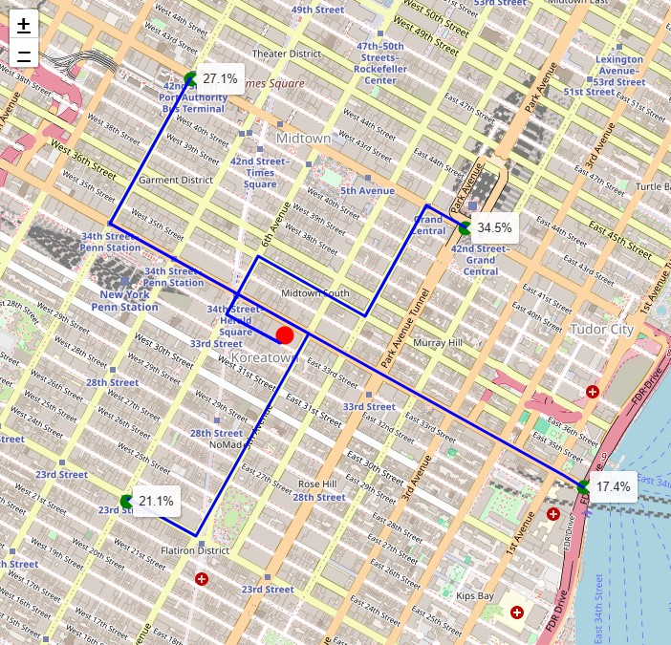
Figure 13: Expected Trip Distribution
The final trip distribution used in the analysis is summarized in Table 9, which can be adapted based on the characteristics of the site and region.
Table 9: Generalized Site Trip Distribution
Direction | Representative Areas / Planning Districts | AM Peak Hour (%) | PM Peak Hour (%)
North | [Insert e.g., Uptown, Midtown, Suburban Areas] | [XX]% In / [XX]% Out | [XX]% In / [XX]% Out
West | [Insert e.g., Downtown Core, Western Suburbs] | [XX]% In / [XX]% Out | [XX]% In / [XX]% Out
East | [Insert e.g., Industrial Districts, Regional Highways] | [XX]% In / [XX]% Out | [XX]% In / [XX]% Out
South | [Insert e.g., Waterfront, Port Lands] | [XX]% In / [XX]% Out | [XX]% In / [XX]% Out
Other / Misc. | [Insert as needed – airport, rural fringe, etc.] | [XX]% In / [XX]% Out | [XX]% In / [XX]% Out
Total |  | 100% | 100%
Note: Consultants should adjust the distribution values based on actual zones, site access constraints, or traffic model outputs, and should ensure that inbound and outbound totals equal 100% for each peak hour.

Trip Assignment
The net site-generated vehicular trips were assigned to the surrounding road network in accordance with the trip distribution described in Section 5.2. The assignment process considered:
- Existing and planned road hierarchies;
- Anticipated routes of least resistance (shortest time or distance);
- Site access locations and restrictions (e.g., right-in/right-out, stop control, signalized access);
- Observed or modeled travel behaviors based on regional travel surveys or traffic simulation.
Inbound trips from various directions are generally expected to approach the site via major arterials, expressways, or regional highways and then transition to collector or local roads to reach the site access points. Similarly, outbound trips are expected to disperse based on proximity to these corridors and overall connectivity.
The assignment takes into account the following assumptions:
- Trips from the north may use a combination of expressways, arterials, or local routes, depending on proximity and available connections.
- Trips from the west or east may use the most direct arterial routes, with preference given to signalized access or unrestricted movements where available.
- Trips from the south may be more limited depending on network availability and geographic constraints (e.g., waterfront, rail lines, etc.).
Where multiple site access points are proposed:
- The primary access point (e.g., a signalized full-movement intersection) is expected to accommodate the majority of inbound and outbound traffic.
- Secondary or auxiliary access points (e.g., right-in/right-out, stop-controlled driveways) will serve a proportion of trips based on operational characteristics and accessibility.
- Directional constraints (e.g., restricted turning movements or geometry) have been considered in assigning trips to each access point.
The assignment of site-generated trips to the adjacent road network is illustrated in Figure 14. Consultants may supplement this with turning movement volumes at study intersections in the future total traffic scenarios.
Note: Trip assignment should be based on engineering judgment, supported by travel demand modeling, origin-destination data, or local traffic studies where available.
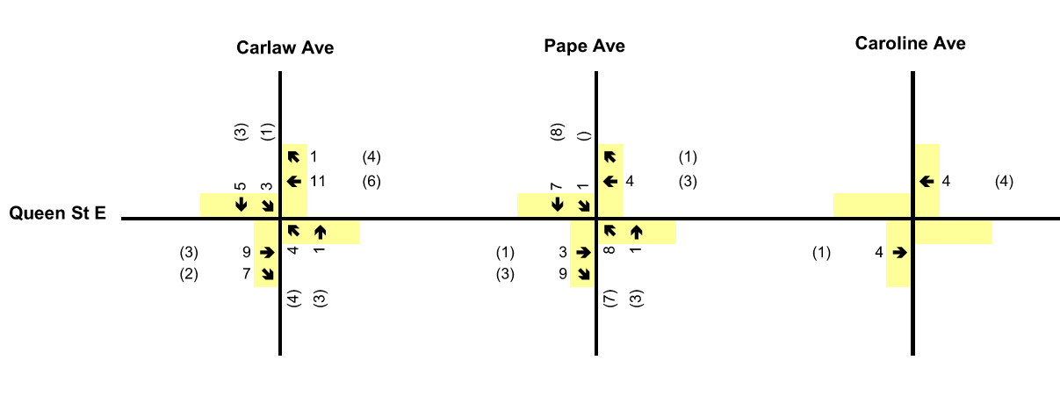
Figure 14: Site Generated Trips

Total Traffic Conditions Analysis
The total traffic volumes for the [Insert Horizon Year / Phase] were developed by combining the net site-generated traffic volumes with the background traffic volumes, which account for:
- Existing traffic conditions;
- Forecasted growth;
- Approved and planned background developments within the study area.
These total future traffic volumes represent the anticipated conditions during the [Insert Time Periods – e.g., AM and PM Peak Hours] and are illustrated in Figure 15.
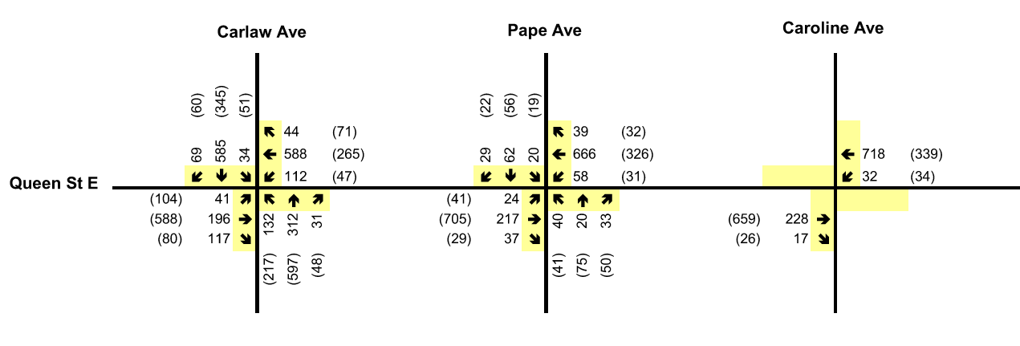
Figure 15: Total Traffic Volumes
A summary of the intersection capacity analysis under total traffic conditions is provided in Table 10. Detailed capacity analysis worksheets, including Levels of Service (LOS), delays, and volume-to-capacity (v/c) ratios for each intersection and movement, are included in Appendix F.
Note: Intersection operations under total traffic conditions should be assessed using industry-standard software (e.g., Synchro, SIDRA) and must reflect updated signal timings, lane configurations, and control types as applicable.
Table 10: Level of Service Analysis – Total Traffic Conditions
Intersection | Control Type | AM Peak Hour |  |  | PM Peak Hour
Intersection | Control Type | LOS | Delay (s) | Critical Movements (v/c) | LOS | Delay (s) | Critical Movements (v/c)
[Insert Intersection Name] | [Signal/ Unsignalized] | A–F | ## | e.g., EB-TR (0.91) | A–F | ## | e.g., NB-L (1.02)
[Insert Intersection Name] | [Signal/ Unsignalized] | A–F | ## | e.g., EB-TR (0.91) | A–F | ## | e.g., NB-L (1.02)
[Insert Intersection Name] | [Signal /Unsignalized] | A–F | ## | e.g., EB-TR (0.91) | A–F | ## | e.g., NB-L (1.02)
… | … | … | … | … | … | … | …
Notes: 1. LOS at an unsignalized intersection is defined by the movement with the highest delay. 2. Critical movements are those with v/c ratios exceeding 0.85 (signalized) or with LOS E/F (unsignalized). Abbreviations: NB = northbound; SB = southbound; EB = eastbound; WB = westbound; L = left; T = through; R = right
Most of the study area intersections are projected to operate at acceptable Levels of Service (LOS) during the weekday AM and PM peak hours, with residual capacity under total future traffic conditions.
Select movements at [Insert Critical Intersection(s)] are forecast to operate near or above capacity. In these cases, v/c ratios exceed 0.90 and delays are elevated, but the marginal increase in v/c (typically less than 0.02) due to site traffic suggests the added impact is minimal. These conditions are generally carried forward from background or existing scenarios.
In particular, [Insert Movement and Intersection (e.g., SB-L at [Intersection])] is projected to operate at LOS E/F, with delays exceeding [insert value] seconds. However, this movement is used by fewer than [insert count] vehicles during the peak hour, indicating low overall impact despite high delay.
Over-capacity conditions are forecast for select critical movements at key intersections, including Intersection A. These constraints are partially carried over from existing and background conditions, where certain turning movements were already operating near or above capacity.
The addition of site-generated trips from Phase X / Sites 1, 2, and 3 contributes to incremental increases in volume-to-capacity (v/c) ratios. For example, at Intersection A, the northbound movement experiences a v/c increase of approximately 0.02 from Site 1, and an additional 0.07 from Sites 2 and 3.
Other intersections with forecasted capacity constraints include:
- Intersection [B]
- Intersection [C]
These locations are expected to continue operating with select movements near or above capacity, although much of this reflects pre-existing network constraints.
The southbound left-turn movement at Intersection D is projected to operate at Level of Service F, with delays of 60 to 90 seconds during the weekday peak hours.

Recommended Improvement: Intersection E: Signalization
The Intersection [E] is forecast to operate at Level of Service F, with significant delays for northbound and southbound stop-controlled movements. These delays are primarily caused by high through volumes on the major road, resulting in insufficient gaps for turning traffic from the minor street.
To address these operational challenges under full build-out conditions, the installation of traffic signals at this intersection was assessed.
Signal Warrant Analysis (OTM Book 12)
A traffic signal warrant analysis was conducted based on projected total traffic volumes, following the methodology in Ontario Traffic Manual (OTM) Book 12. The results are summarized below:
Intersection | Justification 1 | Justification 2 | Warrant Threshold | Signal Warranted?
Intersection E | 100% | 40% | J1 ≥ 100% or (J1 + J2) ≥ 79% | Yes

Detailed warrant calculations are provided in Appendix [X].
As the intersection meets the technical warrants for signalization, installation of traffic signals is recommended to improve operations and facilitate access to and from the development, without significantly impeding through traffic flow on the major road.
A preliminary lane configuration and intersection control layout is shown in Figure [X], illustrating the recommended improvements for future total conditions.

Future Total Traffic Conditions Analysis with Recommended Improvements

Signalized Access and Trip Reassignment
A key intersection [Intersection A] was re-modeled as a signalized intersection with a [90-second cycle length] and a [67/23-second split] for east-west and north-south approaches, respectively. The installation of this traffic signal is expected to influence trip patterns, with more road users utilizing this intersection for site access and egress, reducing reliance on alternative unsignalized intersections.
As a result of this improvement, trip assignments were updated. While traffic originally using other access points (e.g., Access B or Access C) remains largely unchanged, a significant portion of trips was reassigned to the newly signalized intersection, allowing vehicles to enter and exit the site more efficiently.
This shift is also expected to reduce delay and improve the Level of Service (LOS) at nearby intersections, particularly at Intersection B, due to a lower volume of conflicting turning movements. A signal warrant analysis was also updated under the reassigned traffic volumes and confirms that a traffic signal remains warranted. Detailed signal warrant calculations are provided in Appendix [X].
The revised trip assignment and total future traffic volumes are presented in Figure 16 and Figure 17, respectively.
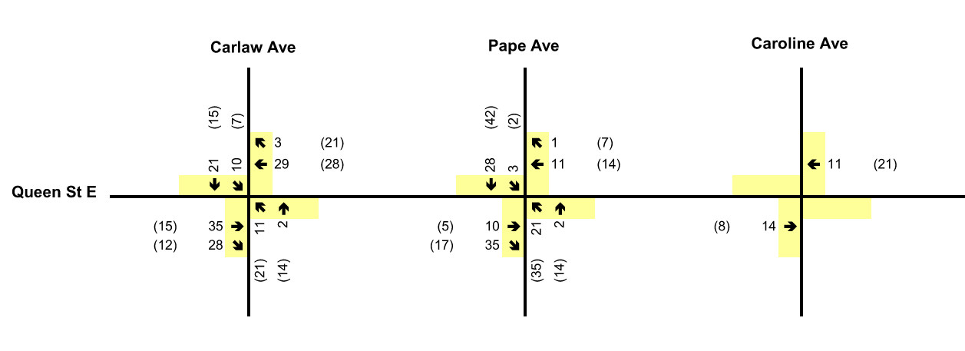
Figure 16: Site Trips Reassignment
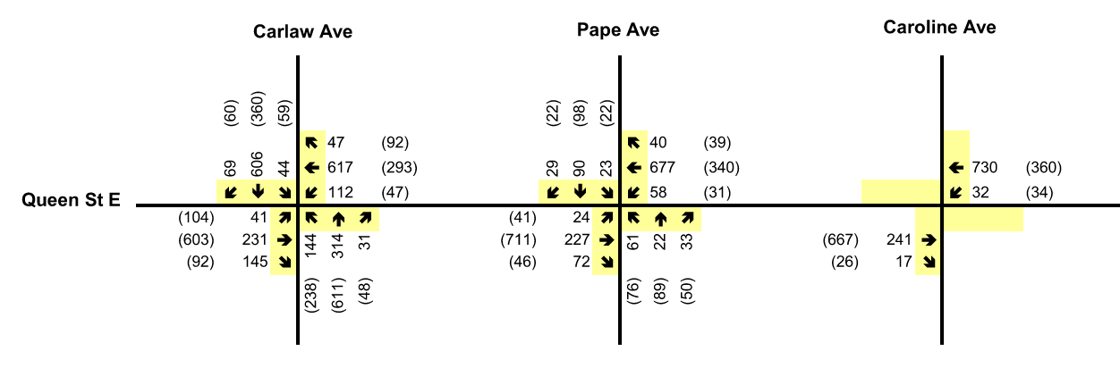
Figure 17: Future Total Traffic Volumes (Reassigned)

Total Traffic Conditions with Improvements
The updated future total traffic conditions were reanalyzed with the recommended improvements in place. Results are summarized in Table 10, and detailed capacity analysis sheets are included in Appendix [X].
Table 12: Level of Service for Future Total Traffic Conditions (Improved)
Intersection | Control Type | AM Peak Hour |  |  | PM Peak Hour
Intersection | Control Type | LOS | Delay (s) | Critical Movements (v/c) | LOS | Delay (s) | Critical Movements (v/c)
[Insert Intersection Name] | [Signal/ Unsignalized] | A–F | ## | e.g., EB-TR (0.91) | A–F | ## | e.g., NB-L (1.02)
[Insert Intersection Name] | [Signal/ Unsignalized] | A–F | ## | e.g., EB-TR (0.91) | A–F | ## | e.g., NB-L (1.02)
[Insert Intersection Name] | [Signal /Unsignalized] | A–F | ## | e.g., EB-TR (0.91) | A–F | ## | e.g., NB-L (1.02)
… | … | … | … | … | … | … | …
Notes: 1. LOS at unsignalized intersections is based on the movement with the highest delay. 2. Critical movements are those with v/c > 0.85 for signalized intersections or LOS E/F for unsignalized intersections.
Abbreviations: NB = northbound, SB = southbound, EB = eastbound, WB = westbound, L = left-turn, T = through, R = right-turn

Key Findings
- With the signalization of Access B and associated trip reassignments, most study intersections continue to operate at acceptable Levels of Service.
- Over-capacity conditions remain at a few key intersections (e.g., Intersections A, F, O, G), largely carried over from existing and background traffic conditions.
- At Access B, signalization improves overall intersection operations from LOS “F” to LOS “D”, with acceptable v/c ratios for all movements.
- Operations at Intersection H are expected to improve due to the reduction in conflicting turn volumes.
- A second signal warrant analysis, reflecting the updated trip assignment, confirms that the traffic signal remains technically warranted. See Appendix [X] for full analysis.

Site Plan Review
A site plan review was conducted using AutoTURN (or equivalent turning simulation software) to confirm that the proposed layout provides adequate maneuverability for various vehicle types typically associated with site operations, including emergency and service vehicles.
The design vehicles used for the analysis included standard templates based on [Transportation Association of Canada (TAC) and/or American Association of State Highway and Transportation Officials (AASHTO)] guidelines. The vehicles assessed typically include:
- Passenger Car
- Medium Single Unit (MSU) Truck
- Heavy Single Unit (HSU) Truck
- Fire Truck
- Police Vehicle
- Garbage Truck
- Ambulance
Vehicle turning templates and dimensions are included in the Appendices.

Minimum Dimensions
Drive aisles, parking stalls, accessible parking spaces, and loading spaces were reviewed for compliance with applicable zoning by-laws and accessibility standards. The review confirmed that the proposed dimensions generally meet or exceed the applicable requirements. Where minor deviations were identified, the functional suitability was reviewed in context of the anticipated usage and vehicle types.
If required, deviations from minimum dimensions for specific uses (e.g., café loading or small delivery zones) should be justified based on:
- Anticipated vehicle types (e.g., small vans or passenger-vehicle-sized delivery vehicles)
- Usage patterns (e.g., low-frequency, off-peak deliveries)
- Physical constraints and site access limitations

Passenger Vehicle Parking and Circulation
Circulation and maneuverability of passenger vehicles were reviewed at all critical locations including:
- Surface parking lots
- Underground or structured parking levels
- Drop-off/pick-up zones
- Access ramps and drive aisles
Simulations illustrate that passenger vehicles can navigate the proposed layout comfortably, with sufficient space for turning, reversing, and entering/exiting parking stalls. The parking layout supports efficient use and safe internal flow throughout the site.
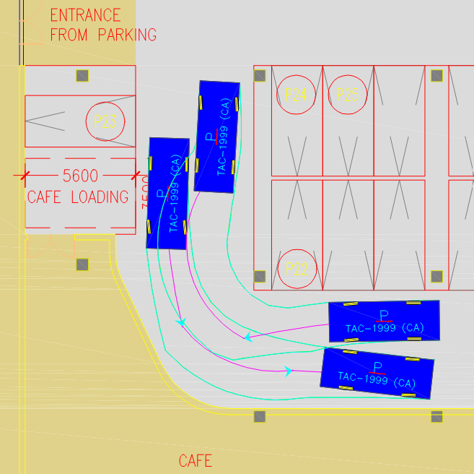
Figure 18: Vehicle Circulation - Passenger Car

Vehicular Circulation
The proposed site circulation was assessed to ensure clear, conflict-free internal movement for both private vehicles and service vehicles. Internal driveways were designed to provide access to parking areas, building entrances, loading zones, and waste collection points.
Key considerations in the circulation review included:
- Adequate turning radii for all design vehicles
- One-way and two-way circulation operations, where applicable
- Access and egress to/from the public road network
- Maneuverability within constrained areas such as loading docks and underground parking ramps
Simulation results confirm that all key vehicle types can circulate within the site without encroachment onto curbs, buildings, or other infrastructure.
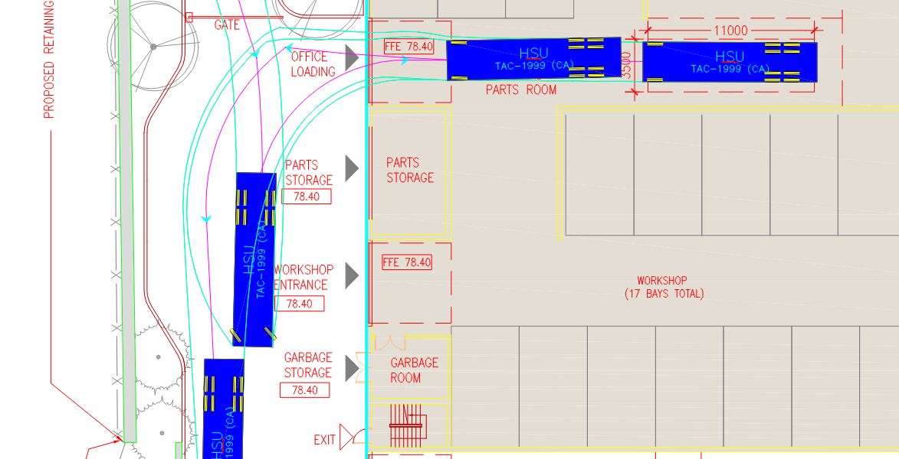
Figure 19: Vehicle Circulation – HSU Truck

Emergency and Service Vehicle Access
Circulation paths for emergency and service vehicles, including Fire Trucks, Ambulances, Police Vehicles, and Garbage Trucks, were reviewed to confirm accessibility to key building entrances and designated servicing areas.
Figures provided in the appendix illustrate:
- Fire truck access and turnaround movements
- Garbage truck circulation to waste collection points
- Ambulance access to main building entrances
- MSU/HSU truck circulation for loading and general deliveries
The review confirms that anticipated vehicle movements can be accommodated within the proposed site layout, subject to final grading and construction details.
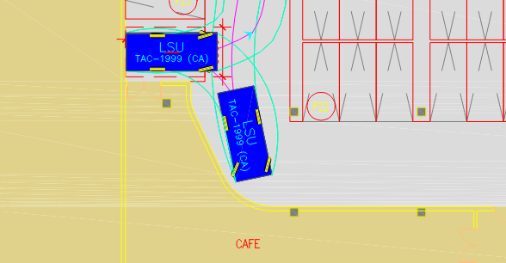
Figure 20: Vehicle Circulation – Fire Truck
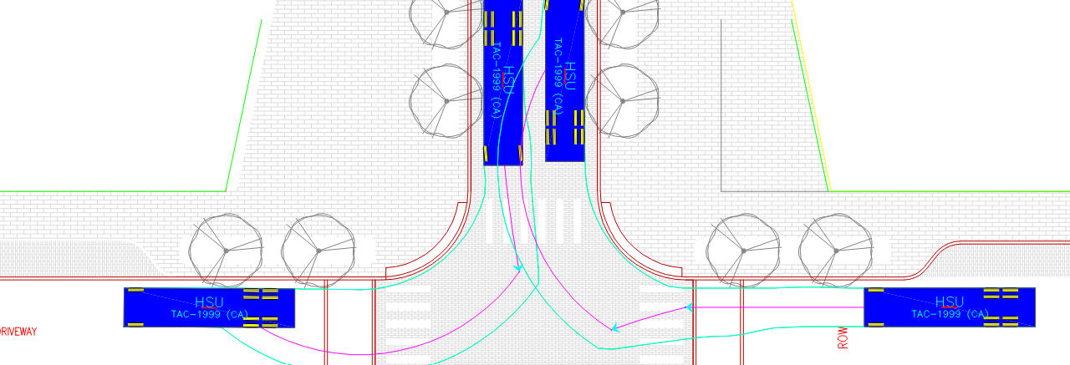
Figure 21: Vehicle Circulation – Ambulance

Pedestrians And Cyclists
The development site is located within an urbanized area characterized by existing or planned walkable infrastructure. The proposed development is expected to enhance the local active transportation network by introducing new pedestrian and cyclist facilities, supporting multi-modal access to and through the site.
A new public road connection is proposed as part of the development, providing an improved north-south link between two major east-west corridors. This connection helps refine the surrounding street grid by filling a significant gap—previously over 400 metres—between adjacent north-south access points. The new link will benefit all modes of travel, including pedestrians and cyclists.
In contrast with the former or existing land use—often industrial or vehicle-oriented—the proposed development includes design elements that encourage walking and cycling. Key land uses such as retail storefronts, cafés, public plazas, and green spaces will serve as attractors for pedestrian and cyclist activity from the surrounding community.
To further promote pedestrian movement:
- Continuous sidewalks will be provided on both sides of the new public street.
- Curb radii and intersection designs will be pedestrian-friendly and compliant with accessibility standards.
- Pedestrian-scale lighting and landscaping will contribute to a safe and inviting environment.
Cyclists will be accommodated via the following measures:
- Shared travel lanes with low posted speeds on internal streets, allowing safe single-file riding alongside vehicles.
- Bicycle parking facilities provided at key site access points and near building entrances.
- Connections to existing or planned cycling infrastructure on surrounding roadways and trails.
The proposed improvements not only support pedestrian and cyclist movement within the development but also contribute to broader regional active transportation goals by enhancing connectivity between existing sidewalks, multi-use trails, and on-street bike lanes.

Transit Impacts
Transit trips are expected to account for approximately 4% to 15% of the total trips generated by the proposed development. These trips will utilize the existing public transit infrastructure serving the surrounding area, including local bus and streetcar routes (or equivalent transit modes).

Existing Transit Services
The study area is currently served by a number of existing public transit routes, which may include:
- Local and express bus routes operating along major arterial roads;
- Streetcar or light rail services along key corridors; and
- Nearby connections to rapid transit or commuter rail lines, where applicable.
These services provide transit accessibility within walking distance of the site and are expected to accommodate a portion of site-generated travel demand.

Planned Transit Improvements
Numerous transit improvements are planned or proposed by the local or regional transit authority that will further enhance access to and from the site. These may include:
- New or upgraded subway/light rail/transitway lines;
- Higher-frequency bus service or bus rapid transit (BRT) on nearby corridors;
- Construction of new transit stations or terminals within proximity to the site; and
- Improved service span and headways on existing routes.
Such enhancements are anticipated to increase the attractiveness of transit use for site-generated trips and reduce reliance on private automobile travel.

Local Improvements
Proposed transit-supportive improvements in the immediate vicinity of the site may include:
- Upgraded bus stops or shelters;
- All-day service on key corridors adjacent to the development;
- Pedestrian-friendly streetscape design to support access to transit.
Together, the existing and future transit infrastructure will provide viable travel alternatives for residents, employees, and visitors of the development, supporting the overall modal split targets identified in this study.

Parking

Applicable By-laws
The Subject Site is located within a jurisdiction that is governed by one or more applicable zoning by-laws. The relevant zoning provisions for parking are based on the [Municipality/City Name] comprehensive zoning by-law, and where applicable, older or site-specific by-laws may also apply. For this assessment, all relevant by-laws have been reviewed to determine the minimum and maximum parking requirements based on the proposed land uses.

Parking Requirements
Table 12 summarizes the minimum and maximum parking requirements for the proposed development, based on the applicable zoning regulations and the preliminary site statistics dated [Insert Date]. The rates vary by land use type and are applied to the proposed gross floor areas.
Table 12: Parking Requirements by Land Use
Land Use Type | Proposed GFA (sq.m.) | Minimum Parking Rate | Maximum Parking Rate | Minimum Required Spaces | Maximum Required Spaces
Office | [XXXX.X] | [X] spaces / 100 sq.m. | [X] spaces / 100 sq.m. | [XX] | [XX]
Retail | [XXXX.X] | [X] spaces / 100 sq.m. | [X] spaces / 100 sq.m. | [XX] | [XX]
Industrial / Institutional / Other | [XXXX.X] | [X] spaces / 100 sq.m. | [X] spaces / 100 sq.m. | [XX] | [XX]
Note: AM, PM, and Evening occupancy factors may be applied where required to calculate time-specific demand.

Proposed Parking Supply
The proposed parking supply has been designed to meet or exceed the minimum requirements while respecting any applicable maximums. Parking is to be provided in a combination of at-grade and structured facilities, with the potential for dedicated spaces for visitors, accessible parking, and electric vehicle charging.
Table 13: Proposed Parking Supply
Parking Type | Location | No. of Spaces
Surface Parking | [e.g., West Side] | [XX]
Covered Parking – Level 1 | [e.g., Ground Level] | [XX]
Covered Parking – Level 2 | [e.g., Above Grade] | [XX]
Total |  | [XXX]

The total proposed parking supply of [XXX] spaces is compliant with the zoning by-law requirements. A portion of the supply may be dedicated to operational needs such as fleet vehicle storage or customer vehicle drop-off, where applicable. Dedicated spaces for electric vehicle charging may also be incorporated.
Future Phases and Flexibility
Where the development consists of multiple phases or parcels, the parking requirements will be refined through subsequent planning approvals. The parking strategy is intended to be flexible and scalable, allowing for adjustments in future Site Plan Control applications, as detailed site programs are finalized.
It is recommended that the applicable zoning by-law(s) be reviewed to determine whether amendments are necessary to harmonize parking requirements across the development site. In cases where older or conflicting by-laws apply, the newer consolidated standard may be adopted for consistency.

Bicycle Parking
The proposed development includes dedicated bicycle parking facilities in accordance with typical urban planning guidelines for active transportation support. These facilities are designed to serve both short-term users (e.g., visitors and customers) and long-term users (e.g., employees and tenants).
Table 14 summarizes the bicycle parking requirements for the proposed development, based on standard rates commonly applied in similar urban contexts. These rates vary depending on land use type and gross floor area.
Table 14: Minimum Bicycle Parking Requirements
Land Use Component | Bicycle Parking Rate | Proposed GFA (sq.m.) | Short-Term Spaces Required | Long-Term Spaces Required
Office | 3 + 0.2/100 sq.m. (short-term)  0.2/100 sq.m. (long-term) | [XXXX] | [X] | [X]
Residential | 3 + 0.2/100 sq.m. (short-term)  0.2/100 sq.m. (long-term) | [XXXX] | [X] | [X]
Retail | 3 + 0.3/100 sq.m. (short-term)  0.2/100 sq.m. (long-term) | [XXXX] | [X] | [X]
Site B Total |  | [XXXX] | [X] | [X]

These requirements result in the following bicycle parking provisions across the development:
- Site A: 13 short-term and 10 long-term bicycle parking spaces
- Site B: 34 short-term and 25 long-term bicycle parking spaces
Bicycle parking will be provided in convenient, secure, and accessible locations throughout the development. Short-term spaces will be located near building entrances, while long-term storage will be provided in enclosed or sheltered areas suitable for day-to-day employee use. These provisions are intended to promote cycling as a viable mode of travel and to support the overall sustainability goals of the development.

Proposed Bicycle Parking Supply
The proposed development includes a dedicated supply of bicycle parking that meets or exceeds the minimum requirements established by applicable municipal standards. Bicycle parking is categorized into two types:
- Short-Term / Visitor Spaces – Intended for customers, visitors, or temporary users.
- Long-Term / Occupant Spaces – Intended for employees or other regular users, typically located in secure, covered areas.
Table 15 summarizes the proposed bicycle parking supply relative to the applicable minimum requirements.
Table 15: Proposed Bicycle Parking Supply
Bicycle Parking Type | Proposed Supply | Minimum Requirement (By-law A) | Minimum Requirement (By-law B)
Short-Term / Visitor | [X] | [X] | [X]
Long-Term / Occupant | [X] | [X] | [X]
Total | [X] | [X] | [X]

The proposed bicycle parking supply exceeds the minimum requirements under all relevant zoning by-laws, supporting the development’s objective to encourage active transportation.
Future phases of the development (Sites B and C) are expected to include additional office, retail, and service-oriented uses. Bicycle parking supply for these future sites will be provided in accordance with the same standards, ensuring compliance and consistency across the full build-out of the development.
Bicycle parking facilities will be distributed strategically throughout the site to maximize accessibility, security, and user convenience.

Loading

Zoning By-law Loading Requirements
The proposed development is subject to loading space requirements as outlined in the applicable municipal zoning by-law. Loading space requirements are based on the gross floor area and use of the development components (e.g., office, retail, automotive, etc.).
Table 16 summarizes the required loading spaces by type for each site within the development.
Table 16: Loading Space Requirements (Zoning By-law)
Land Use | By-law Category | Type A | Type B | Type C
Office | [Applicable Floor Area Range] | 0 | 1 | 2
Automotive Use | [Applicable Floor Area Range] | – | – | –
Retail | [Applicable Floor Area Range] | 0 | X | X
Restaurant | [Applicable Floor Area Range] | 0 | X | X
Note: Placeholder values to be replaced with actual data as per final site plans.

Proposed Loading Supply
The proposed development includes a mix of loading space types that are designed to support site operations while satisfying or exceeding the minimum zoning requirements. Loading spaces are categorized as:
- Type A: Large loading bays (long combination vehicles)
- Type B: Medium-sized loading bays (single-unit trucks)
- Type C: Small bays for light- and medium-duty vehicles
Table 17 summarizes the loading space supply for Site A.
Table 17: Proposed Loading Space Supply
Type | Number of Spaces | Dimensions | Zoning Requirement Met
Type A | 0 | – | Yes/No
Type B | 1 | [e.g., 11m x 3.5m] | Yes
Type C | 1 | [e.g., 5.6m x 3.5m] | Yes
Total Spaces | [X] | – | –

One [Type B] space is proposed to support general office and light industrial operations.
One [Type C] space is intended to serve smaller commercial uses (e.g., a café or service unit).
An oversize loading space has been designed to accommodate larger deliveries such as infrequent automotive shipments or multiple smaller trucks. Due to its size and flexible use, this oversize space is considered functionally equivalent to multiple smaller loading bays.
Overall, the loading facilities satisfy the applicable municipal zoning requirements.

Travel Demand Management Strategies
To mitigate the transportation impacts of the proposed development and encourage sustainable travel choices, a set of Travel Demand Management (TDM) strategies are recommended. These strategies aim to reduce single-occupancy vehicle (SOV) trips and promote transit use, walking, cycling, and shared mobility options. Based on industry guidance and previous case studies, the combined implementation of these strategies is estimated to achieve an SOV reduction of approximately [10–25%], depending on site-specific conditions and the level of uptake.
Transit Subsidies
Providing transit pass subsidies to building occupants, tenants, or employees can significantly shift travel behavior from private vehicles to public transit. Monthly discounts, pre-loaded fare cards, or employer-sponsored programs can make transit a more attractive and cost-effective option. This measure alone can contribute to a [5–10%] reduction in SOV trips.
Bicycle Infrastructure and Facilities
The provision of secure, well-located long-term and short-term bicycle parking, along with end-of-trip facilities such as showers and lockers, encourages cycling as a viable commute option. If implemented alongside cycling education or incentive programs, this strategy can reduce SOV trips by [2–5%], especially for short-distance trips under 5 km.
Carpooling and Rideshare Programs
Establishing an on-site carpool matching service, preferred parking for carpools, or participation in regional rideshare platforms can support a culture of shared commuting. These programs may reduce SOV trips by [3–8%], depending on the nature of employment or tenancy at the site.
Unbundled Parking
Separating the cost of parking from lease or residential unit prices discourages vehicle ownership and incentivizes alternative travel modes. By making parking an optional and paid feature, this strategy can lead to a [5–10%] reduction in SOV demand, particularly in higher-density or transit-rich areas.
Active Transportation Enhancements
Improving pedestrian pathways, implementing wayfinding signage, and ensuring strong connectivity to nearby cycling networks can further encourage non-motorized modes of travel. These enhancements support both health and mobility objectives, contributing to a [1–3%] reduction in vehicle trips, particularly for nearby destinations.
Mobility Hub Features
Where feasible, integrating mobility hub features—such as shared bike stations, carshare vehicles, e-scooter docks, or transit screens—within the site can provide first-mile/last-mile solutions and reduce reliance on private vehicles. These facilities are increasingly effective in urban contexts and can yield an additional [3–6%] reduction in SOV trips when bundled with other strategies.

Conclusions
Based on the analysis presented in this report, the following conclusions are drawn:
The majority of intersections within the study area are currently operating at acceptable Levels of Service (LOS), while select intersections or movements are approaching or exceeding capacity under existing conditions.
The proposed development is anticipated to generate additional traffic volumes that may increase delays for certain movements at key intersections, particularly during peak hours.
Site access is proposed via the following connections:
- [Access 1: e.g., existing driveway on ___ Road/Avenue]
- [Access 2: e.g., new intersection at ___ Street and ___ Avenue]
- [Access 3: e.g., right-in/right-out access on ___ Road]
Traffic generated by [Development] can be accommodated by the planned and existing road network. No off-site mitigation measures are recommended at this time, as:
- Most study intersections are projected to operate at acceptable LOS.
- Some movements may continue to operate over capacity due to background conditions.
- Minor delays are expected at [specific intersection or movement], but these are not anticipated to result in network-wide impacts.
Traffic associated with [Future Development] can be managed with network enhancements such as:
- The installation of a traffic signal at [Intersection Name Placeholder], which is projected to alleviate congestion and improve operations.
- Signal warrants are expected to be met under future conditions with the proposed development in place.
A limited number of intersections (e.g., [Intersection A], [Intersection B], etc.) are forecast to continue operating over capacity, with constraints largely carried over from existing and background conditions.
All anticipated on-site vehicular operations, including truck turning movements, can be accommodated within the development limits.
The proposed vehicle and bicycle parking supply for [Development] is consistent with the requirements of applicable zoning by-laws [e.g., Zoning By-law XXXX].
The proposed loading facilities for [Site A / Phase 1] adequately support the forecast operational needs and meet or exceed by-law requirements.

Recommendations
To support the implementation of the proposed development, the following site access and circulation measures are recommended:
- Provide vehicular access through:
  - [Access 1 description — e.g., a right-in/right-out driveway on ___]
  - [Access 2 description — e.g., new full-movement intersection at ___]
  - [Access 3 description — e.g., existing driveway to be retained on ___]
  - [Optional internal connections — e.g., private loop road, shared laneways]
- Construct sidewalks on both sides of [Internal Road Name Placeholder] to enhance pedestrian connectivity within the site and to adjacent neighborhoods and trails.
- Accommodate cyclists using [shared lanes / dedicated lanes / multi-use paths] along [Internal Road Name Placeholder], consistent with the local road classification and intended operating speeds.
- Ensure that the proposed parking and bicycle parking supply for [Site A / Sites A–C] satisfies the minimum requirements of [Zoning By-law XXXX], including any recent amendments regarding accessible parking dimensions.
- Provide on-site loading spaces as follows:
  - Type B loading space(s)
  - Type C loading space(s) with minimum dimensions of [e.g., 5.6m x 3.5m], suitable for [e.g., small retail or café use]
Additional transportation studies may be required at the time of detailed site planning or rezoning for [Future Phases / Sites B and C], to assess site-specific traffic, parking, and loading operations, as determined by the reviewing agency.
In addition to site-specific recommendations, the following background network improvements—previously identified by the municipality or in other planning studies—are supported by the findings of this study:
a. Extension or realignment of [Road Name Placeholder] to improve connectivity
b. Signalization of intersections at [Intersection 1 Placeholder] and [Intersection 2 Placeholder]
c. Removal of redundant or underutilized signals at [Intersection Placeholder]
d. Introduction or enhancement of public transit service along [Corridor Placeholder]
e. Future rapid transit infrastructure such as [Planned Subway / BRT Line Placeholder]
f. Implementation of active transportation improvements including sidewalks, bike lanes, or trails in the vicinity of the site.

Appendices

Appendix A - Terms of Reference

Appendix B – Traffic Count Sheets

Appendix C – Signal Timing Plans

Appendix D – Existing Scenario Synchro Output Files

Appendix E – Future Background Synchro Output Files

Appendix F - Future Total Synchro Output Files

Appendix G - Future Total with Improvements Synchro Output Files

Appendix H - Vehicle Turning Templates

